**FOR T.D.C PART- II (GEOGRAPHY SUBSIDIARY)**

**Paper – 4th (Economic Geography)**

**BY**

**Dr. ALPNA JYOTI**

**Deptt. of Geography, Marwari College, Darbhanga**

**LNM University, Darbhanga**

**Q. – *Iron–Ore (DIST. & PRODUCTION ) OF World :-***

***Iron Ore Distribution: World***

Iron ore is the most important mineral that is used to extract metallic Iron by Iron and Steel Industry. Extracted metal is widely used by secondary industries for manufacturing of machines, machine tools, construction of buildings etc. It is the most widely used metal because of its certain qualities like hardness, strength and durability. Further, iron is malleable and possess magnetic properties. Hence, Iron, because of its significance in manufacturing and development of infrastructure has wide economic importance.

***The iron ore is found in following four types:***

***Magnetite*** *:*

It is the most important and best kind of iron ore. It contains about 72 percent metallic iron in it. It is black in colour. The key economic parameters for magnetite ore being economic are the crystallinity of the magnetite, the grade of the iron within the banded iron formation host rock, and the contaminant elements which exist within the magnetite concentrate. The size and strip ratio of most magnetite resources is irrelevant as a banded iron formation can be hundreds of meters thick, extend hundreds of kilometers along [strike](https://en.wikipedia.org/wiki/Strike_and_dip), and can easily come to more than three billion or more tonnes of contained ore.

The typical grade of iron at which a magnetite-bearing banded iron formation becomes economic is roughly 25% iron, which can generally yield a 33% to 40% recovery of magnetite by weight, to produce a concentrate grading in excess of 64% iron by weight. The typical magnetite iron-ore concentrate has less than 0.1% [phosphorus](https://en.wikipedia.org/wiki/Phosphorus), 3–7% [silica](https://en.wikipedia.org/wiki/Silica) and less than 3% [aluminium](https://en.wikipedia.org/wiki/Aluminium). Currently magnetite iron ore is mined in [Minnesota](https://en.wikipedia.org/wiki/Minnesota) and [Michigan](https://en.wikipedia.org/wiki/Michigan) in the [U.S.](https://en.wikipedia.org/wiki/United_States), Eastern [Canada](https://en.wikipedia.org/wiki/Canada) and Northern [Sweden](https://en.wikipedia.org/wiki/Sweden). Magnetite-bearing banded iron formation is currently mined extensively in [Brazil](https://en.wikipedia.org/wiki/Brazil), which exports significant quantities to [Asia](https://en.wikipedia.org/wiki/Asia), and there is a nascent and large magnetite iron-ore industry in [Australia](https://en.wikipedia.org/wiki/Australia).

Occasionally [granite](https://en.wikipedia.org/wiki/Granite) and [ultrapotassic](https://en.wikipedia.org/wiki/Ultrapotassic) [igneous rocks](https://en.wikipedia.org/wiki/Igneous_rock) segregate [magnetite](https://en.wikipedia.org/wiki/Magnetite) crystals and form masses of magnetite suitable for economic concentration. A few iron ore deposits, notably in [Chile](https://en.wikipedia.org/wiki/Chile), are formed from [volcanic](https://en.wikipedia.org/wiki/Volcanic) flows containing significant accumulations of magnetite [phenocrysts](https://en.wikipedia.org/wiki/Phenocryst).[[7]](https://en.wikipedia.org/wiki/Iron_ore#cite_note-ChileIronOxideLava-7) Chilean magnetite iron ore deposits within the [Atacama Desert](https://en.wikipedia.org/wiki/Atacama_Desert) have also formed [alluvial](https://en.wikipedia.org/wiki/Alluvial) accumulations of magnetite in streams leading from these volcanic formations.

Some magnetite [skarn](https://en.wikipedia.org/wiki/Skarn) and [hydrothermal](https://en.wikipedia.org/wiki/Hydrothermal) deposits have been worked in the past as high-grade iron ore deposits requiring little [beneficiation](https://en.wikipedia.org/wiki/Beneficiation). There are several granite-associated deposits of this nature in [Malaysia](https://en.wikipedia.org/wiki/Malaysia) and [Indonesia](https://en.wikipedia.org/wiki/Indonesia).

Other sources of magnetite iron ore include metamorphic accumulations of massive magnetite ore such as at [Savage River](https://en.wikipedia.org/wiki/Savage_River,_Tasmania), [Tasmania](https://en.wikipedia.org/wiki/Tasmania), formed by shearing of [ophiolite](https://en.wikipedia.org/wiki/Ophiolite) [ultramafics](https://en.wikipedia.org/wiki/Ultramafic" \o "Ultramafic).

Another, minor, source of iron ores are magmatic accumulations in [layered intrusions](https://en.wikipedia.org/wiki/Layered_intrusion) which contain a typically [titanium](https://en.wikipedia.org/wiki/Titanium)-bearing magnetite often with [vanadium](https://en.wikipedia.org/wiki/Vanadium). These ores form a niche market, with specialty smelters used to recover the iron, titanium and vanadium. These ores are beneficiated essentially similar to banded iron formation ores, but usually are more easily upgraded via [crushing](https://en.wikipedia.org/wiki/Crusher) and [screening](https://en.wikipedia.org/wiki/Mechanical_screening). The typical titanomagnetite concentrate grades 57% Fe, 12% Ti and 0.5% V.

### *****Hematite******:*

**It is also an important source. It contains about 60-70 percent** **metallic iron in it. It is red and brown in colour.**

Direct-shipping iron-ore (DSO) deposits (typically composed of [hematite](https://en.wikipedia.org/wiki/Hematite)) are currently exploited on all continents except [Antarctica](https://en.wikipedia.org/wiki/Antarctica), with the largest intensity in [South America](https://en.wikipedia.org/wiki/South_America), Australia and Asia. Most large hematite iron-ore deposits are sourced from altered banded iron formations and rarely igneous accumulations.

DSO deposits are typically rarer than the magnetite-bearing BIF or other rocks which form its main source or protolith rock, but are considerably cheaper to mine and process as they require less beneficiation due to the higher iron content. However, DSO ores can contain significantly higher concentrations of penalty elements, typically being higher in phosphorus, water content (especially [pisolite](https://en.wikipedia.org/wiki/Pisolite) sedimentary accumulations) and aluminium ([clays](https://en.wikipedia.org/wiki/Clay_mineral) within pisolites). Export-grade DSO ores are generally in the 62–64% Fe range.

**Limonite**:

It contains about 30 to 40 percent metallic iron in it. It is mostly yellow in colour. It is a low-grade iron ore.

**Siderite**:

It has more impurities. It contains about 48 percent metallic iron content in it. It is brown in colour. It contains a mixture of iron and carbon. It is a low-grade iron ore.

***Available world iron ore resources***

Iron is the most abundant element on earth but not in the crust. The extent of the accessible iron ore reserves is not known, though [Lester Brown](https://en.wikipedia.org/wiki/Lester_R._Brown) of the [Worldwatch Institute](https://en.wikipedia.org/wiki/Worldwatch_Institute" \o "Worldwatch Institute) suggested in 2006 that iron ore could run out within 64 years (that is, by 2070), based on 2% growth in demand per year. Iron ore is widely distributed around the world. China is the world's largest producer of iron-ore followed by Brazil and Australia at the second and third position respectively. Majority of the world's total reserves of iron ore of 3,20,000 million tonnes is located in North America, Russia, United Kingdom, Brazil, South Africa and India.

***United States***

In 2014 mines in the [United States](https://en.wikipedia.org/wiki/United_States) produced 57.5 million metric tons of iron ore with an estimated value of $5.1 billion. [Iron mining in the United States](https://en.wikipedia.org/wiki/Iron_mining_in_the_United_States) is estimated to have accounted for 2% of the world's iron ore output. In the United States there are twelve iron ore mines with nine being [open pit mines](https://en.wikipedia.org/wiki/Open-pit_mining) and three being reclamation operations. There were also ten pelletizing plants, nine concentration plants, two direct-reduced iron (DRI) plants and one iron nugget plant that where operating in 2014. In the United States the majority of iron ore mining is in the [iron ranges](https://en.wikipedia.org/wiki/Iron_Range) around [Lake Superior](https://en.wikipedia.org/wiki/Lake_Superior). These iron ranges occur in [Minnesota](https://en.wikipedia.org/wiki/Minnesota) and Michigan which combined accounted for 93% of the usable iron ore produced in the United States in 2014. Seven of the nine operational open pit mines in the United States are located in Minnesota as well as two of the three tailings reclamation operations. The other two active open pit mines were located in [Michigan](https://en.wikipedia.org/wiki/Michigan), in 2016 one of the two mines shut down.[[30]](https://en.wikipedia.org/wiki/Iron_ore#cite_note-:1-30) There have also been iron ore mines in [Utah](https://en.wikipedia.org/wiki/Utah) and [Alabama](https://en.wikipedia.org/wiki/Alabama); however, the last iron ore mine in Utah shut down in 2014[[30]](https://en.wikipedia.org/wiki/Iron_ore#cite_note-:1-30) and the last iron ore mine in Alabama shut down in 1975.

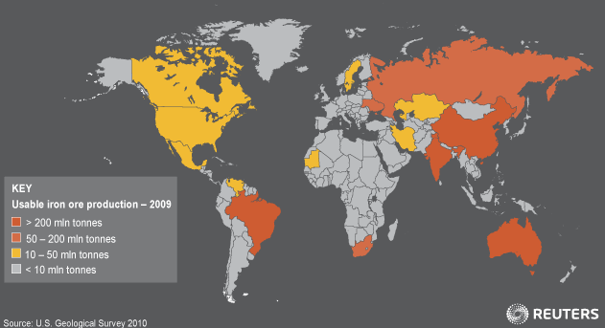

*Figure showing iron ore production across the world*

***Russia***

It has one of the largest proven reserves of iron ore. Important iron-producing regions of Russia are the Ural region, Kuzkas region in Siberia, Angara and Krasnoyarsk.

***Ukraine***

Good quality ore with high iron content is found in Kirvoj Rog region of Southern Ukraine, Kursk Magnetic Anomaly(KMA) and Kerch peninsula.

***Europe***

Sweden is an important region where good quality iron ore is found. Major areas of iron-ore mining in Sweden include Kiruna, Gallivare and Danmora. Another important region is Lorraine in France. Apart from this, Normandy, Pyrenees, Selsia and Phalia region of Germany, and Cleveland, Midland and Scotland region of United Kingdom are major mining ore areas of Europe.

***North America***

The major iron ore mining areas are the Lake Superior region including Mesabi, Vermillion, Marquette, Cuyana, Manomimi and Gogebic; Alabama state including the Birmingham and Red Mountain region of South Applatians; and in Canada including the Wright, Sept Isles and Schefferville regions.

***Canada***

In 2017 Canadian iron ore mines produced 49 million tons of iron ore in concentrate pellets and 13.6 million tons of crude steel. Of the 13.6 million tons of steel 7 million was exported, and 43.1 million tons of iron ore was exported at a value of $4.6 billion. Of the iron ore exported 38.5% of the volume was iron ore pellets with a value of $2.3 billion and 61.5% was iron ore concentrates with a value of $2.3 billion.[[32]](https://en.wikipedia.org/wiki/Iron_ore#cite_note-:2-32) The majority of Canada's iron ore comes from [Nunavut](https://en.wikipedia.org/wiki/Nunavut) and from [Labrador](https://en.wikipedia.org/wiki/Labrador) along the [Quebec](https://en.wikipedia.org/wiki/Quebec) and [Newfoundland and Labrador](https://en.wikipedia.org/wiki/Newfoundland_and_Labrador) border.

***Brazil***

Brazil is known for its one of the largest reserves of iron ore in the world. Other important regions of iron ore mining are Orinoco Valley of Venezuela and La Sarena area of Chile.

 Brazil is the second largest producer of iron ore with [Australia](https://en.wikipedia.org/wiki/Australia) being the largest. In 2015 Brazil exported 397 million tons of usable iron ore.[[30]](https://en.wikipedia.org/wiki/Iron_ore#cite_note-:1-30) In December 2017 Brazil exported 346,497 metric tons of iron ore and from December 2007 to May 2018 they exported a monthly average of 139,299 metric tons.

***Africa***

The major iron ore mining areas of Africa are Liberia, South Africa, Algeria, Morocco and Tunisia. The iron and steel industry of Africa is still under-developed. As a result, most of the iron is exported

***Australia***

[Geoscience Australia](https://en.wikipedia.org/wiki/Geoscience_Australia) calculates that the country's "[economic demonstrated resources](https://en.wikipedia.org/wiki/Economic_demonstrated_resources)" of iron currently amount to 24 [gigatonnes](https://en.wikipedia.org/wiki/Tonne" \l "Derived_units" \o "Tonne), or 24 billion tonnes.[[citation needed](https://en.wikipedia.org/wiki/Wikipedia:Citation_needed)] The current production rate from the [Pilbara](https://en.wikipedia.org/wiki/Pilbara) region of [Western Australia](https://en.wikipedia.org/wiki/Western_Australia) is approximately 430 million tonnes a year and rising. Gavin Mudd ([Monash University](https://en.wikipedia.org/wiki/Monash_University)) and Jonathon Law ([CSIRO](https://en.wikipedia.org/wiki/CSIRO)) expect it to be gone within 30–50 years and 56 years, respectively.[[26]](https://en.wikipedia.org/wiki/Iron_ore#cite_note-26) These estimates require on-going review to take into account shifting demand for lower-grade iron ore and improving mining and recovery techniques In 2011, leading Pilbara-based iron ore miners—Rio Tinto, BHP Billiton and Fortescue Metals Group (FMG)—all announced significant capital investment in the development of existing and new mines and associated infrastructure (rail and port). Collectively this would amount to the production of 1,000 million tonnes per year (Mt/y) by 2020. Practically that would require a doubling of production capacity from a current[[when?](https://en.wikipedia.org/wiki/Wikipedia:Manual_of_Style/Dates_and_numbers#Chronological_items)] production level of 470 Mt/y to 1,000 Mt/y (an increase of 530 Mt/y). These figures are based on the current[[when?](https://en.wikipedia.org/wiki/Wikipedia:Manual_of_Style/Dates_and_numbers#Chronological_items)] production rates of Rio 300 Mt/y, BHP 240 Mt/y, FMG 55 Mt/y and Other 15 Mt/y increasing to Rio 360 Mt/y, BHP 356 Mt/y, FMG 155 Mt/y and Other 140 Mt/y (the latter 140 Mt/y is based on planned production from recent[[when?](https://en.wikipedia.org/wiki/Wikipedia:Manual_of_Style/Dates_and_numbers#Chronological_items)] industry entrants Hancock, Atlas and Brockman through [Port Hedland](https://en.wikipedia.org/wiki/Port_Hedland,_Western_Australia) and API and others through the proposed [Port of Anketell](https://en.wikipedia.org/wiki/Anketell_Port)). In March 2014, Fortescue officially opened its 40-million-tonne-per-annum (mtpa) Kings Valley project, marking the completion of a US$9.2 billion expansion that increased its production capacity to 155 mtpa. The expansion included the construction of the greenfields Solomon Hub in the Hamersley Ranges, one of the world's largest iron ore developments comprising Kings Valley and the nearby 20 mtpa Firetail mine; an expansion of the Christmas Creek mine to 50 mtpa; and major extensions of Fortescue's world-class port and rail facilities.

A production rate of 1,000 Mt/y would require a significant increase in production from existing mines and the opening of a significant number of new mines. Further, a significant increase in the capacity of rail and port infrastructure would also be required. For example, Rio would be required to expand its port operations at Dampier and Cape Lambert by 140 Mt/y (from 220 Mt/y to 360 Mt/y). BHP would be required to expand its Port Hedland port operations by 180 Mt/y (from 180 Mt/y to 360 Mt/y). FMG would be required to expand its port operations at Port Hedland by 100 Mt/y (from 55 Mt/y to 155 Mt/y). That is an increase of 420 Mt/y in port capacity by the three majors Rio, BHP and FMG and about at least 110 Mt/y from the non-major producers. Based on the rule-of-thumb of 50 Mt/y per car dumper, reclaimer and ship-loader the new production would require approximately ten new car dumpers, reclaimers and ship-loaders.

New rail capacity would also be required. Based on the rule-of-thumb of 100 Mt/y per rail line, increasing production by approximately 500 Mt/y would require five new single rail lines. One scenario is an extra rail line for all the majors: BHP (from double to triple track), Rio (double to triple track), FMG (single to double track) and at least two new lines. Hancock Prospecting has recently[[when?](https://en.wikipedia.org/wiki/Wikipedia:Manual_of_Style/Dates_and_numbers#Chronological_items)] started production from its Roy Hill Iron Ore Mine located north of Newman. This project included the development of the Roy Hill deposit, the construction of a 344 km railway and a port facility with an annual throughput of 55 Mt and QR National to service non-major producers, as of December 2015 due to the falling iron ore price these plans have been suspended indefinitely.

A 1,000 Mt/y production rate needs to be further considered by proponents and government. Areas of further consideration include new port space at Anketell to service the West Pilbara mines, growth at Port Hedland (BHP has announced the development of an outer harbour at Port Hedland), rail rationalisation and the regulatory approval requirements for opening and maintaining a ground disturbance footprint that supports 1,000 Mt/y of production including, amongst other things, native title, aboriginal heritage and environmental protection outcomes.

***Distribution of Iron Ore in India***

India is one of the richest countries of the world in iron ore deposits, particularly the hematite ore. According to the latest Indian Year Book, 95 percent of the hematite resources are distributed in Odisha, Jharkhand, Karnataka and Goa. Magnetite resources are estimated at around 10,619 million tons out of which only 59 million tons is situated mainly in Goa, Rajasthan and Jharkhand. The rest 10,560 million tons or the 99 percent of the magnetite resource is in 'Remaining Resources' category which is mainly found in Karnataka (74 %) and Andhra Pradesh (14 %).

***Iron Ore reserves (in descending order)***

1. Karnataka
2. Odisha
3. Jharkhand
4. Chhattisgarh

#### ****Iron Ore production (in descending order)****

Odisha

Goa

Karnataka

Chhattisgarh

The iron ore is widely distributed in the country:

Karnataka has more than half of the reserves of magnetite ore in India.

Jharkhand has the highest reserves of haematite ore in India.

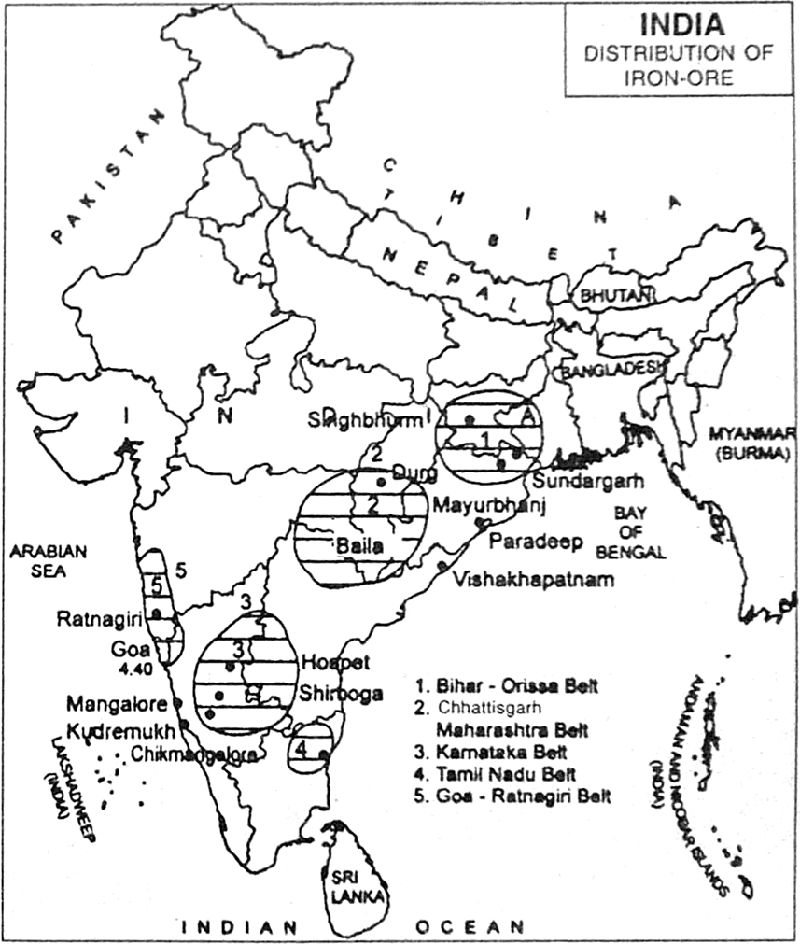

##### ****Jharkhand****

##### The iron ores here exist as hill masses which are close to coal fields. The iron ore generally occurs at the top of the hills, iron ore mining companies use aerial ropeways for bringing down the ore and pumping it into the railway wagons standing near the foot of the hills. The major iron ore mining areas in Jharkhand are Noamudi, Gua, Jamda and Kiriburu.

***Chhattisgarh***

Exploitable rich iron deposits are located in Dalli-Rajhara region of Durg district (close to Bhilai Steel Works), Bailadilla region of Dantewada district, Arindogi region and Raoghat region.

***Odisha***

The major iron ore mining centre is in Singhbhum district. The districts of Keonjhar, Mayurbhanj and Sundargarh also form the richest reserves of quality iron ore. The iron ore available here is Hematite which has about 60-70 percent metallic iron content. The iron ore from these sites is supplied to the iron and steel factories located at Rourkela, Jamshedpur, Asansol and Durgapur. The ore is also exported to different countries through the Paradip port.

***Goa***

The major iron ore mining centres are Sanguem, Safari, Ponda, Sahqualim, Bicholim and Quepem. The iron ore found in Goa is of high quality. The mining centres are located close to the port of Marmagao. The mines are worked by open-cast methods. They are close to rivers which enter the sea near the port. The iron ore is brought by road to jetties on the navigable rivers from which it is taken away to port for onward journey.

***Karnataka***

In Karnataka, the major iron ore mining areas are Baba Budan Hills, Kudremukh region, Hospet, Bellary, Chitradurga and Tumkur district. Iron-ore mined in Bellary and Hospet area is transported to Hospet from where it is sent to the ports of Chennai and Marmagao through railways for export to other countries.

**Maharashtra**

Maharashtra produces a very small amount of iron ore. Major mining ore areas include Chandrapur, Ratnagiri and Bhandara districts.

***Andhra*** ***Pradesh***

Iron ore is mined in small quantities in districts of Karimnagar, Warangal, Cuddapah, Kurnool, Adilabad and Anantapur.

Tamil Nadu

In Tamil Nadu, the areas where iron ore is mined are Tirthamalai Hills in Salem district and Yadpalli and Killiomalai areas in Nilgiris.

**Iron ore market**

Over the last 40 years, iron ore prices have been decided in closed-door negotiations between the small handful of miners and [steelmakers](https://en.wikipedia.org/wiki/Steelmaking) which dominate both spot and contract markets. Traditionally, the first deal reached between these two groups sets a *benchmark* to be followed by the rest of the industry.[[3]](https://en.wikipedia.org/wiki/Iron_ore#cite_note-Iron_ore_pricing-3)

In recent years, however, this benchmark system has begun to break down, with participants along both demand and supply chains calling for a shift to short term pricing. Given that most other [commodities](https://en.wikipedia.org/wiki/Commodity) already have a mature market-based pricing system, it is natural for iron ore to follow suit. To answer increasing market demands for more transparent pricing, a number of financial exchanges and/or clearing houses around the world have offered iron ore swaps clearing. The CME group, SGX (Singapore Exchange), London Clearing House (LCH.Clearnet), NOS Group and ICEX (Indian Commodities Exchange) all offer cleared swaps based on The Steel Index's (TSI) iron ore transaction data. The CME also offers a Platts-based swap, in addition to their TSI swap clearing. The ICE (Intercontinental Exchange) offers a Platts-based swap clearing service also. The swaps market has grown quickly, with liquidity clustering around TSI's pricing.[[21]](https://en.wikipedia.org/wiki/Iron_ore#cite_note-21) By April 2011, over US$5.5 billion worth of iron ore swaps have been cleared basis TSI prices. By August 2012, in excess of one million tonnes of swaps trading per day was taking place regularly, basis TSI.

A relatively new development has also been the introduction of iron ore options, in addition to swaps. The CME group has been the venue most utilised for clearing of options written against TSI, with open interest at over 12,000 lots in August 2012.

[Singapore Mercantile Exchange](https://en.wikipedia.org/wiki/Singapore_Mercantile_Exchange) (SMX) has launched the world first global iron ore futures contract, based on the [Metal Bulletin](https://en.wikipedia.org/wiki/Metal_Bulletin) Iron Ore Index (MBIOI) which utilizes daily price data from a broad spectrum of industry participants and independent Chinese steel consultancy and data provider Shanghai Steelhome's widespread contact base of steel producers and iron ore traders across China.[[](https://en.wikipedia.org/wiki/Iron_ore#cite_note-22) The futures contract has seen monthly volumes over 1.5 million tonnes after eight months of trading.This move follows a switch to index-based quarterly pricing by the world's three largest iron ore miners—[Vale](https://en.wikipedia.org/wiki/Vale_(company)), [Rio Tinto](https://en.wikipedia.org/wiki/Rio_Tinto_(corporation)) and [BHP](https://en.wikipedia.org/wiki/BHP)—in early 2010, breaking a 40-year tradition of benchmark annual pricing.

-------------------------------------------------------------------------------00000-------------------------------------------------------------------------------------------